

Deploy Website on Amezon S3

Assingment

Rudresh sisode | Web Development | 06/06/2019

* Now I already created a very pretty website with also include all feature which I used while created.

To host my application on amazon s3 cloud server, I need to create first Amezon Web Services Web services account. At <https://aws.amazon.com/>

* I’m Already created my own account.

Now, Click on Services

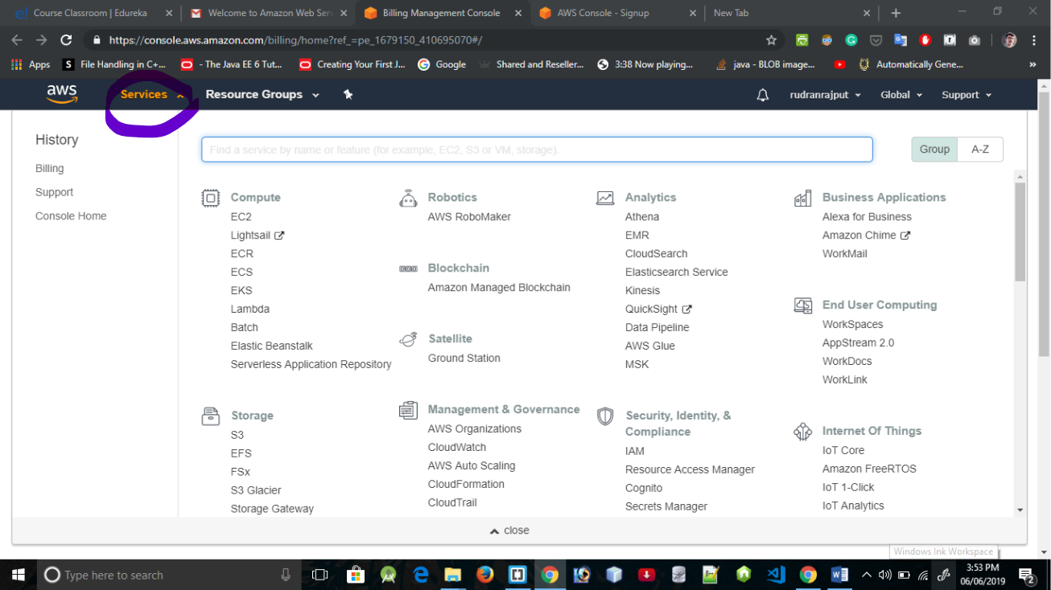

* Then Click on Storage and then select S3.

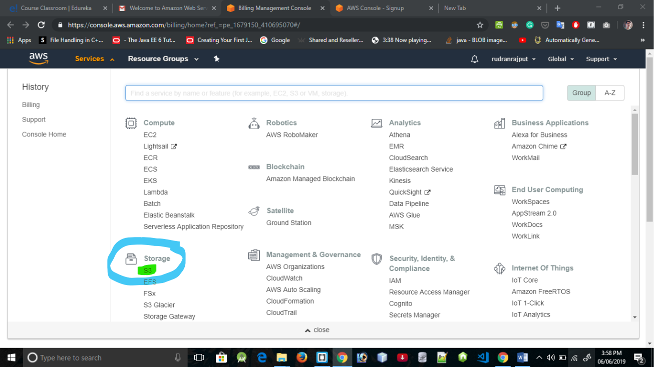

* Here I have already login to my account now here, I have to crate bucket under S3 service. An S3 bucket will keep all my files.

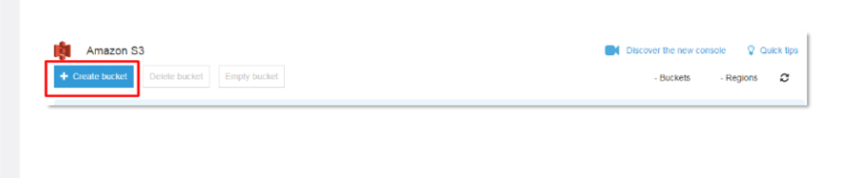

* It will ask you some of configuration for next 3 to 4 step, Once you completed.

Right click on the Bucket list, click on the property.

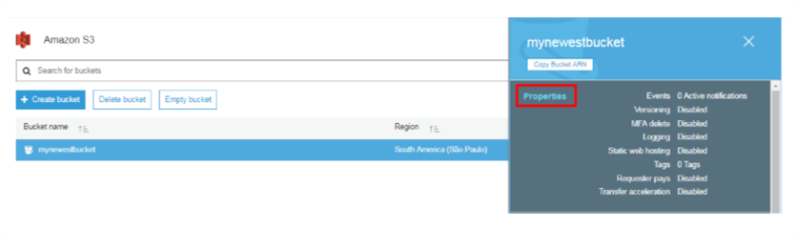

* Then, Enable “static website hosting” clicking on that tab.

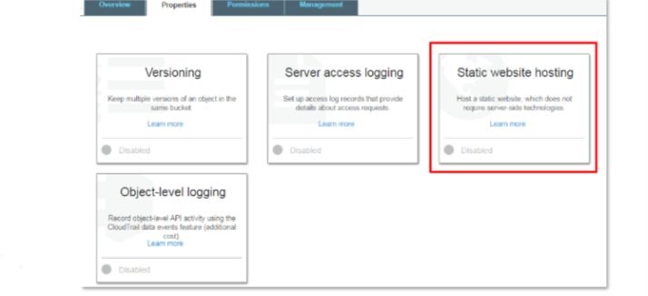

* Then, Select the use this bucket to host the website radio button and provide the index document name. 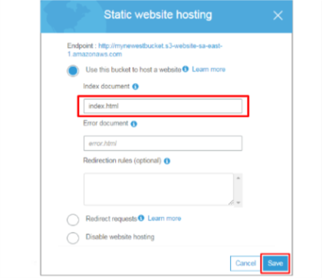
* Put below bucket policy in the bucket policy editor and click o save. This bucket policy will allow every use to access your S3 bucket.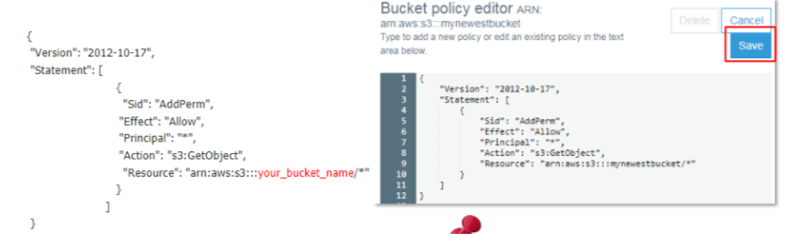

Then, Simply click on upload button to upload your file into bucket.

* Now in the file upload window click on add file button and selct the file you want to upload. After that click on next.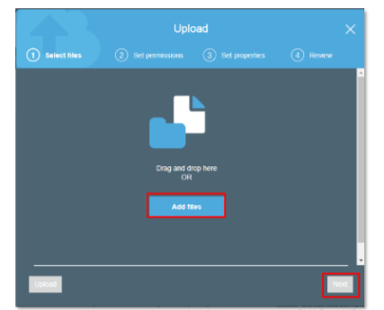
* Now go next with clicking on default on setting. Then click on Upload button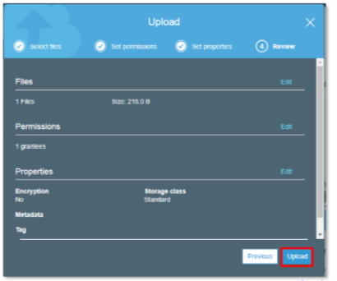
* Once uploaded you can see the link for the file in Overview tab or you can double click on file.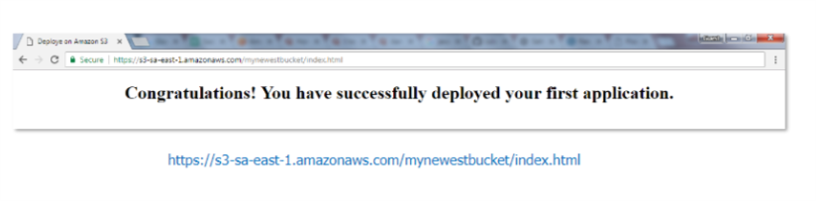
* Now your file has been successfully upload on Amezon S3.